Definition of cloud computing by National Institute of Standards and Technology (NIST):

Cloud computing is a model for enabling ubiquitous, convenient, on-demand network access to a shared pool of configurable computing resources (e.g., networks, servers, storage, applications, and services) that can be rapidly provisioned and released with minimal management effort or service provider interaction.

Definition 2:

It is an emerging IT infrastructure paradigm where data and services reside in massively scalable data centres and can be ubiquitously accessed from any connected devices over the internet.

Definition of what a cloud service is:

It is any IT resource that is made remotely accessible via a cloud. A cloud refers to a distinct IT environment that is designed for the purpose of remotely provisioning scalable and measured IT resources.

Grid Computing: This involves many computers which work together on a problem that requires a large amount of computational power.

Utility Computing: Only pay as much resource as you use.

Software as a Service: Application is licensed for use as a service provided to customers on demand.

Cloud Computing uses the technologies from Grid Computing, utility computing and Software as a Service.

Cloud Computing Value Drivers

1. Immediate access to hardware resources thus **faster time to market** business.
2. Pay-per-use billing dramatically **reduces upfront costs.**
3. **Easy to scale** services in response to client demand.
4. **Increases interoperability** between disjoint technologies.

Characteristics of Cloud Computing

Virtual – Physical location and underlying infrastructure details are hidden from the consumer.

Scalable – Able to distribute workloads into pieces served across and incrementally expandable infrastructure.

Elastic – allows to use as many resources as needed, can also reduce.

Efficient -

Flexible – Can serve a variety of workload types – both consumer and commercial.

The Conceptual Reference Model 

Cloud Consumer: A person or organisation that maintains a business relationship with and uses service from Cloud Providers.

Cloud Provider: A person, organisation, or entity responsible for making a service available to interested parties.

Cloud Delivery Models

Represents a specific, pre-packaged combination of IT resources offered by a cloud provider.

Infrastructure-as-a-Service (IaaS)

Platform-as-a-Service (PaaS)

Software-as-a-Service (SaaS)

Infrastructure-as-a-Service

* hardware and very low-level software
* Includes hardware, network, operating systems, drivers etc.
* Virtualised and packaged into bundles
* Requires some level of configuration

Platform-as-a-Service (PaaS)

* Ready to use environment
* Built on top of Infrastructure-as-a-service
* Already configured.
* Software building blocks
* Pre-packaged products and tools used to support the entire delivery lifecycle.

Software-as-a-Service (SaaS)

* Built on top of IaaS and PaaS
* Software products shared as a cloud utility.
* Used to make reusable cloud service widely available to a range of cloud consumers.



Scope of Controls

* Cloud software is installed/managed/maintained by SaaS providers, or PaaS and IaaS consumers.
* Software building blocks at the middleware layer are used by PaaS consumers.
* Operating system and drives at the operating system layer are hidden from both SaaS and PaaS consumers, and are controlled by both the IaaS provider and consumers.



Cloud Consumer’s Concerns

* Portability: Ability to transfer data and applications to other clouds at low cost and minimal difficulty
* Interoperability: ability to use data and services across multiple cloud provider with a unified management interface.
* Security: Ranges from physical security to application security

Cloud Deployment Models

* Public Cloud
* Private Cloud
* Community Cloud
* Hybrid Cloud

Public Cloud

* Available to anyone
* Provided by a third party
* Involves the public internet.

Private Cloud

* Owned by a single cloud consumer organisation
* Managed by cloud consumer organisation or third party.
* May be on-sit or outsourced to a hosting company.



Community Cloud





* Similar to public cloud, but the consumers are limited to a community
* Cloud may be owned by community or third party.

Hybrid Cloud

* Contains two or more different cloud deployment models
* Models are bound together by standardized or proprietary technology.
* Allows data to be flexibly stored.

Costs

* The costs of cloud computing and local computational resources can be calculated using **Capital Expenditure and Operational Expenditure.**
* The benefits of cloud computing may not only relate to finance and may be difficult to quantify.

The Cost of Ownership (TCO)

* The sum of all associated costs relating to the purchase, ownership, usage and maintenance of a particular product.



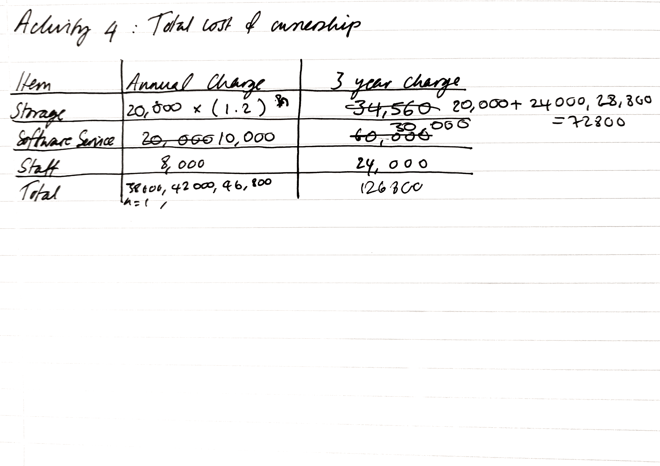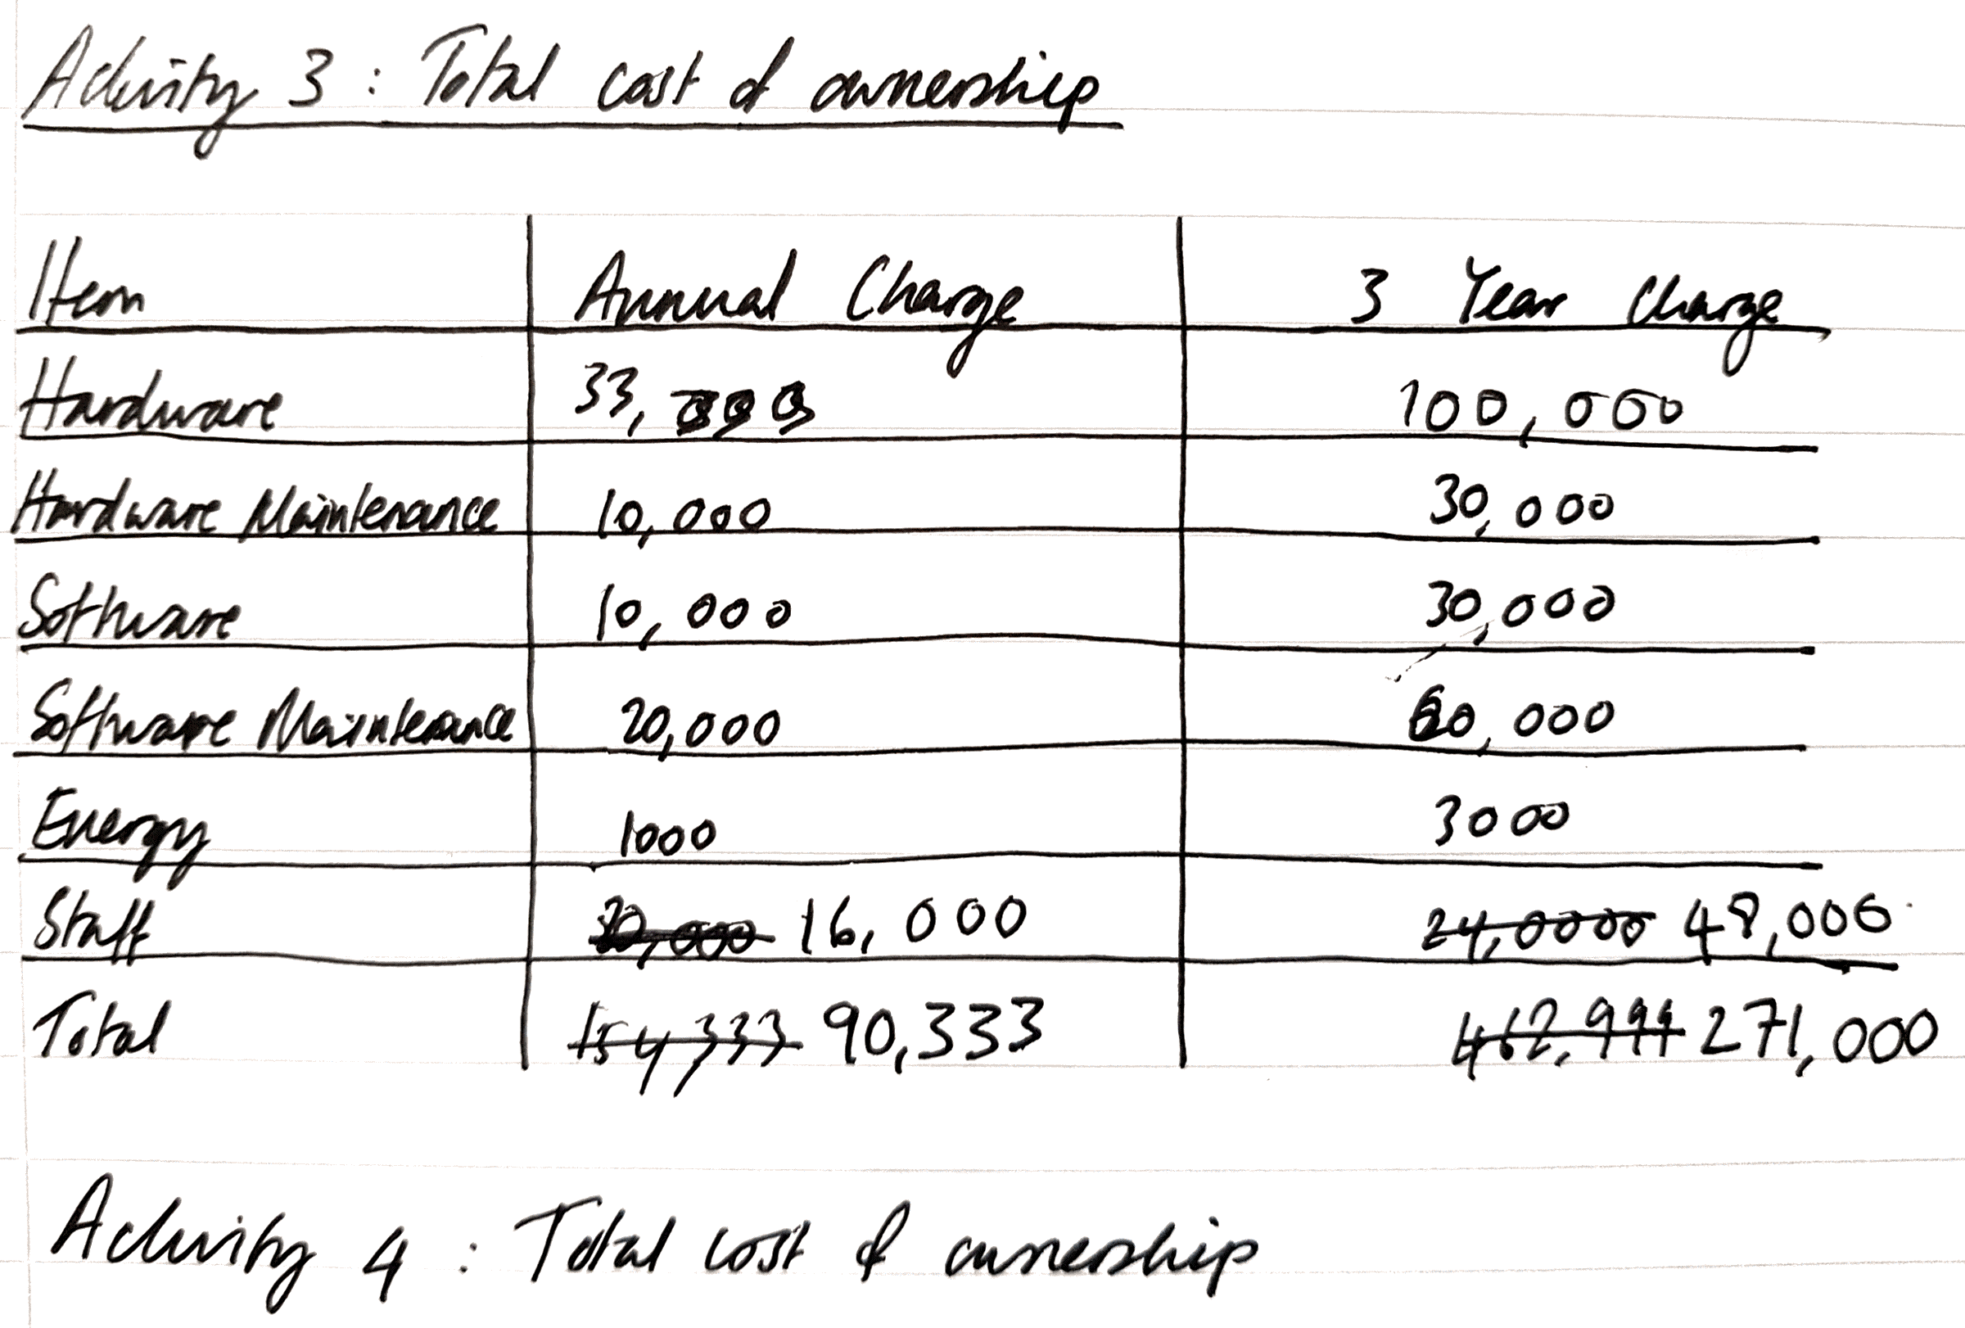



Other Metrics Not-Quiet Financial Metrics

* Availability
* Time to market
* Churn rate

Return on Investment (ROI)

* Money made on investment
* ROI = (Gain from investment – Cost of investment) / Cost of Investment
* ROI gives the net money made per pound of investment.
* Does not take into account that this money made, could be investment to make more money.

Net Present Value (NPV)

* Determines the expected level of return from an investment before it is considered worthwhile.
* Discount the future return down to its present value using: